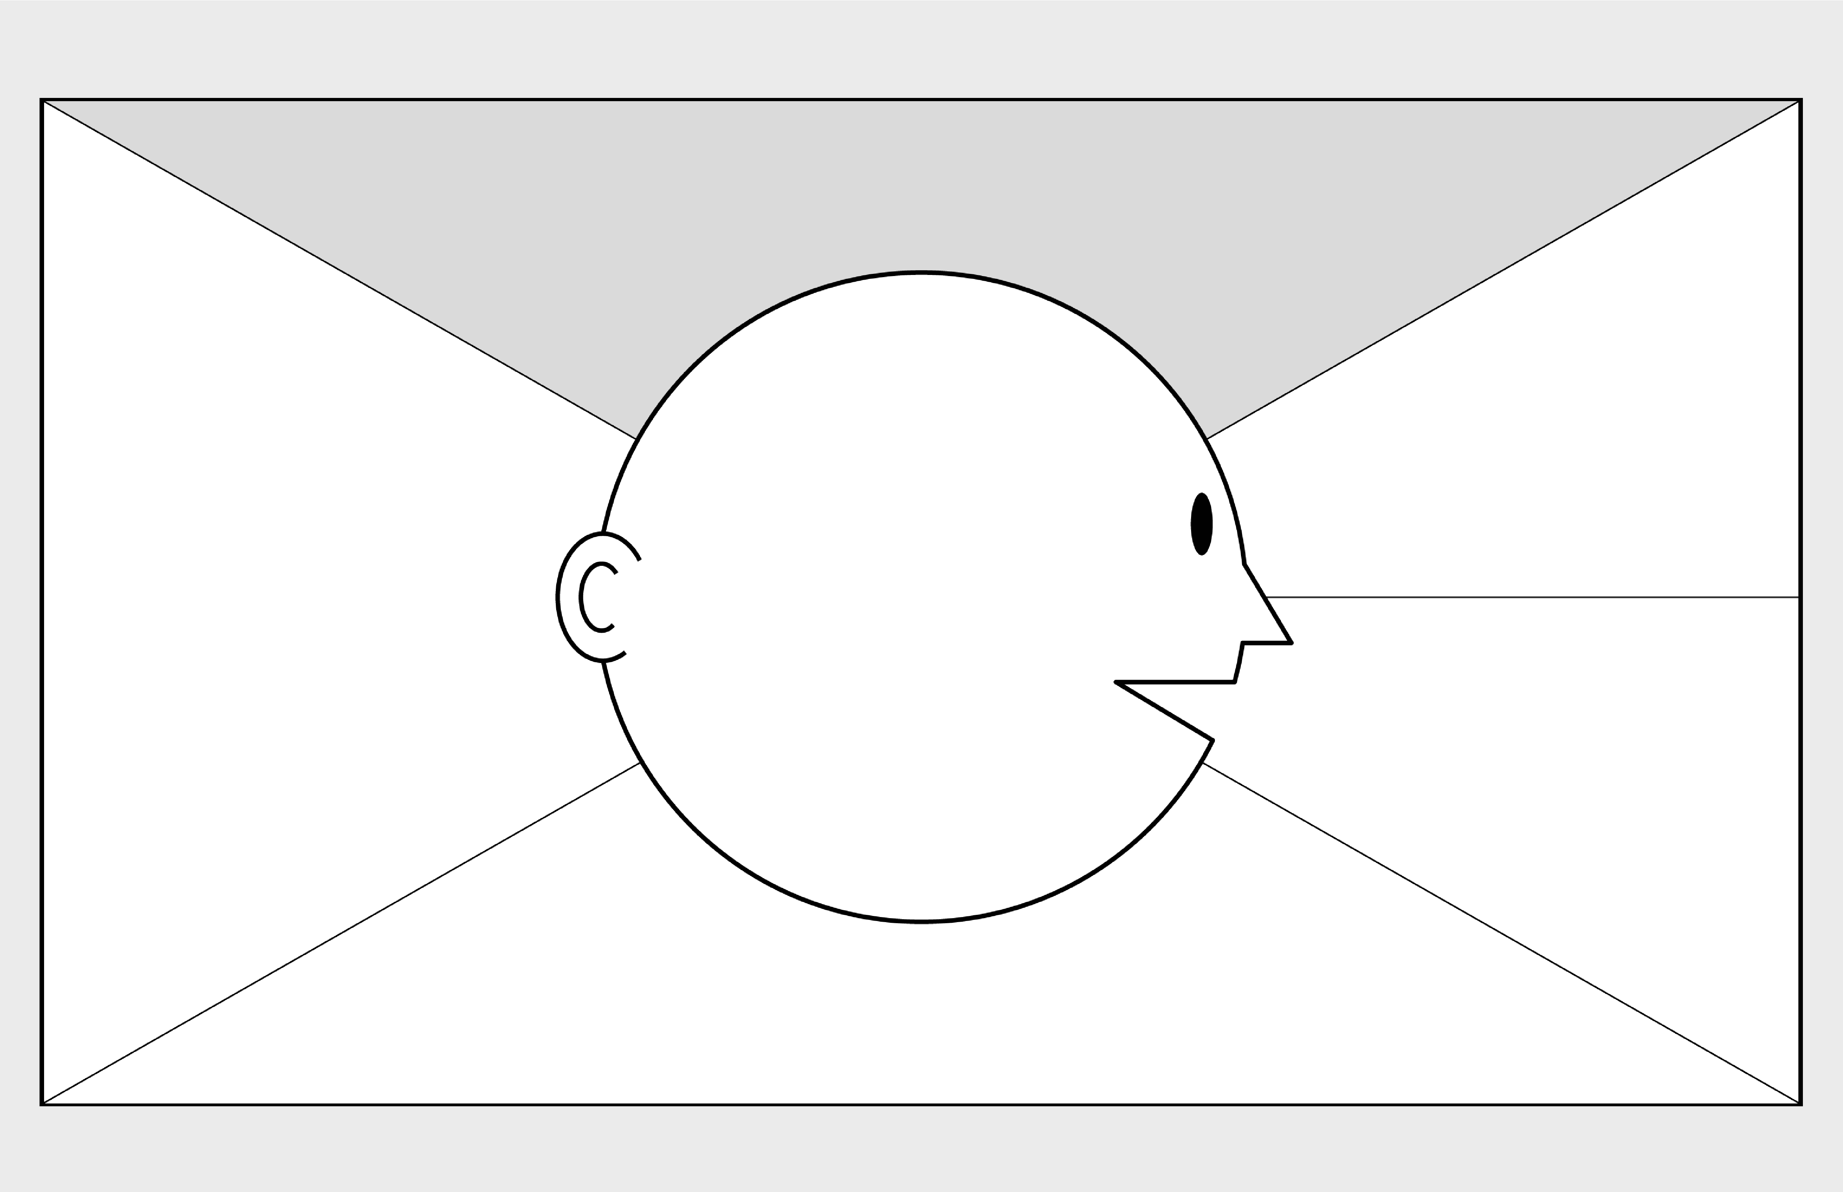

**Empathy Map Canvas on Crude oil**

**WHO**

**are we empathizing with?**

**What do they need to DO**

**?**

Create fuel for the vehicles of all size

Refined the fuel easily

Indian oil Corporation Ltd

Manage the demand

**GOAL**

**What do they**

**SEE**

**?**

**What do they**

**SAY**

**?**

**What do they**

**DO**

**?**

**What do they**

**HEAR**

**?**

**What do they**

**THINK**

**and**

**FEEL**

**?**

Decline of the demand

Polluted the environment

Use me in limit

They run our ecosystem

Use more and pollute less

Electric will replace it

Future is no more

-

-

**1**

**2**

**3**

**4**

**5**

**6**

**7**

**PAINS**

**GAINS**

Future is no more

Eco-Friendly Environment

other thoughts and feelings might motivate their behavior